**SOFTWARE DEVELOPMENT**

Data Modeling for EcoBikeRental

1. **Conceptual Data Model**

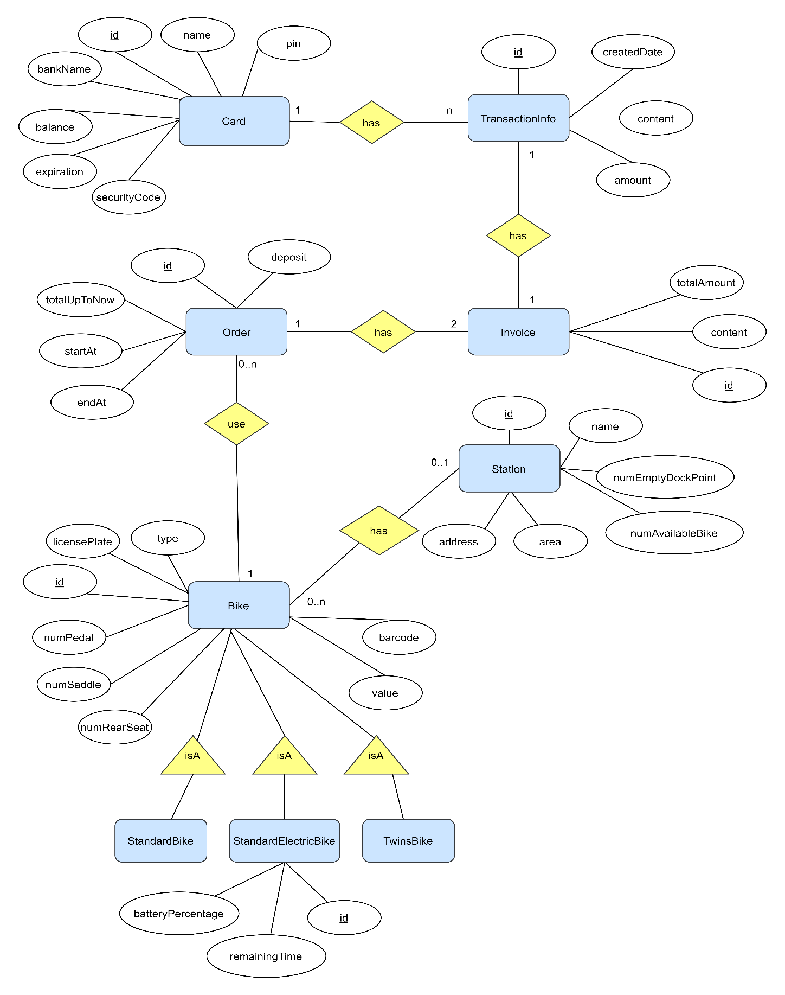

*Figure1. ER Diagram*

1. **Logical Data Model**

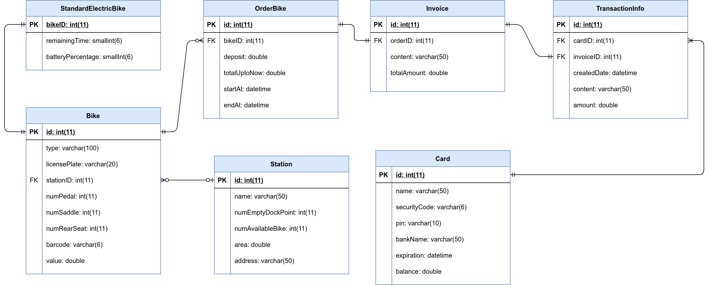

*Figure2. Relational Diagram*

1. **Physical Data Model**

* **Card**

|  |  |  |  |  |  |  |
| --- | --- | --- | --- | --- | --- | --- |
| # | PK | FK | Column name | Data type | Mandatory | Description |
| 1 | x |  | id | Integer | Yes | ID of card,  auto increment |
| 2 |  |  | name | Varchar(50) | Yes | Name of Card’s holder |
| 3 |  |  | securityCode | Varchar(6) | Yes | Security code of card |
| 4 |  |  | pin | Varchar(10) | Yes | PIN number |
| 5 |  |  | bankName | Varchar(50) | Yes | Name of Interbank |
| 6 |  |  | expiration | datetime | Yes | Expiration date of card |
| 7 |  |  | balance | double | Yes | Balance of card |

* **TransactionInfo**

|  |  |  |  |  |  |  |
| --- | --- | --- | --- | --- | --- | --- |
| # | PK | FK | Column name | Data type | Mandatory | Description |
| 1 | x |  | id | Integer | Yes | ID of transaction,  auto increment |
| 2 |  |  | content | Varchar(50) | Yes | Content of transaction |
| 3 |  | x | cardID | Integer | Yes | cardID, same as ID of  card which is used for the transaction |
| 4 |  | x | invoiceID | Integer | Yes | invoiceID, same as ID of invoice which belongs to the transaction |
| 5 |  |  | createDate | datetime | Yes | Creation date of the transaction |
| 6 |  |  | amount | double | Yes | Total amount of money is used for the transaction |

* **Station**

|  |  |  |  |  |  |  |
| --- | --- | --- | --- | --- | --- | --- |
| # | PK | FK | Column name | Data type | Mandatory | Description |
| 1 | x |  | id | Integer | Yes | ID of station,  auto increment |
| 2 |  |  | name | Varchar(50) | Yes | Name of the station |
| 3 |  |  | numEmptyDockPoint | Integer | Yes | Number of empty dock points in the station |
| 4 |  |  | numAvailableBike | Integer | Yes | Number of available bike for renting in the station |
| 5 |  |  | area | double | Yes | Area of the station |
| 6 |  |  | address | varchar(50) | Yes | Address of the station |

* **Database Script:**

CREATE TABLE Card(

id INT AUTO_INCREMENT PRIMARY KEY,

NAME VARCHAR(50) not null,

securityCode VARCHAR(6) not null,

pin VARCHAR(10) not null,

bankName VARCHAR(50) not null,

expiration DATETIME not null,

balance DOUBLE not null

);

CREATE TABLE Order (

id INT AUTO_INCREMENT PRIMARY KEY,

deposit double not null,

totalUpToNow DOUBLE not null,

bikeID int not null,

startAt DATETIME not null,

endAt DATETIME,

FOREIGN KEY bikeID REFERENCES Bike(id)

);

CREATE TABLE Invoice(

id INT AUTO_INCREMENT PRIMARY KEY,

content VARCHAR(50) not null,

totalAmount DOUBLE not null,

orderID int not null,

FOREIGN KEY orderID REFERENCES Order(id)

);

CREATE TABLE TransactionInfo(

id INT AUTO_INCREMENT PRIMARY KEY,

cardID INT,

invoiceID INT,

createdDate DATETIME,

content VARCHAR(50),

amount DOUBLE,

FOREIGN KEY cardID REFERENCES Card(id),

FOREIGN KEY invoiceID REFERENCES Invoice(id)

);

CREATE TABLE Station(

id INT AUTO_INCREMENT PRIMARY KEY,

name VARCHAR(50) not null,

numEmptyDockPoint INT not null,

numAvailableBike INT not null,

area DOUBLE not null,

address VARCHAR(50) not null

);